The Author of the Truth

For the word of God is living and active, and sharper than any two-edged sword; and pierces to the point of dividing the soul and the spirit, the joints and the marrow, and discerns the thoughts and intentions of the heart. Hebrews 4:12

The Bible is the Revelation of God, inspired by the Holy Spirit.

- Revelation: refers to how God has made Himself known, communicating with particular people at specific times.

- A loving God required that this truth be available to all, hence in His wisdom the Bible was conceived, the book that compiled God's communication in History, in divine discourse, and in the life and work of Jesus.

- Inspiration: By Inspiration of Scripture, we mean the supernatural influence of the Holy Spirit on the authors of the Bible, which guarantees that what they wrote is, in fact, the word of God.

The Bible Is Reliable:

"The way we use and approach the Bible will be influenced by what we think of it."

What is the process by which we have the Bible today?

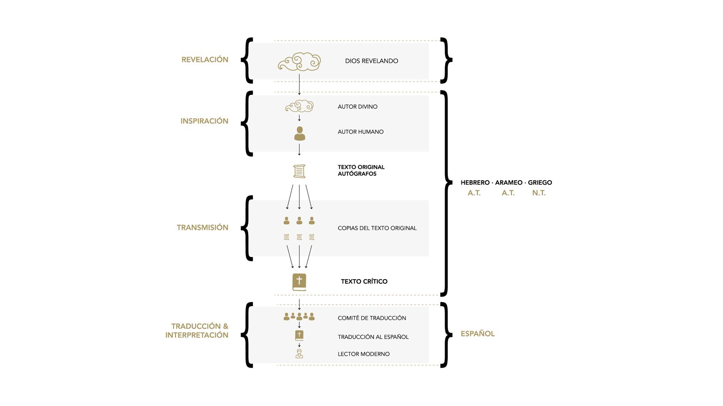
- Every Historical Document has to pass three tests:

- a) Bibliographic evidence.

- b) Internal evidence evidence.

- c) Proof of external evidence.

- d) The Prophetic Trial:

"The Bible is the word of God, a divine message given to us in human language. And it has the answer to life's toughest questions: Does God exist? What is God like? Where do we come from? Why are we here? How will this all end?"

The Bible is Authority:

"The more we are subject to authority, the simpler our life will be.” Watchman Nee.

- Is there a person, institution, or document that possesses the right to prescribe belief and action in spiritual matters?

- If there is a supreme being greater and wiser than humans and everything else in the created order, don't you think He will have the right to dictate what we are to believe in and how we are to live? God is authority, because of who He is.

I am the Alpha and the Omega, the beginning and the end, says the Lord, the One who is and who was and who is to come, the Almighty. Revelation 1:8

- One of the ways God has delegated His authority is by creating a book, the Bible, that has His message and carries the same weight as if God were speaking directly to us.

- The Bible, as the expression of God's will for us, has the right to define what we believe in and how we are to conduct ourselves.

"The Bible is a sure source of direction, because when it is correctly interpreted, it is totally truthful in all its teachings."

- We can say that it is a safe and reliable authority.

Evidence for why we should appoint the Bible as authority:

1. Jesus saw the Old Testament as authoritative and inspired:

Have you not read," Jesus answered, "that in the beginning the Creator "created them male and female" and said: "Therefore a man shall leave his father and mother and be joined to his wife." and the two will become one"?
Matthew 19:4

2. The consensus of the Historical Church:
- The historical consensus of the Church is that it is authoritative and trustworthy in all that it affirms:

3. Is there another more reliable authority?
- Culture: Everyone is doing it.
- Tradition: We have always done it this way.
- The Reason: It seems logical to me.
- Emotions: It feels good.

- Many of our problems are because we base our decisions on untrustworthy authorities, and when you disqualify the Bible, you are putting another authority in God's place: where will it lead you?

Summary:
- The Bible has to become the authority in my life. It is the compass I rely on for direction, the comfort I hear in making wise decisions, and the standard I use to evaluate everything.

- The Bible, being the word of God, has to have the last word in my life.

- We must decide that regardless of culture, tradition, reason, emotions, we choose the Bible as our final authority.

- Always asking: What does the Bible say? before making a decision.

"Think Biblically About Everything."

Questions and Passages for Further Study
PAZ Groups

Jesus answered, "It is written, 'Man does not live by bread alone, but by every word that proceeds from the mouth of God.'" Matthew 4:4

1. Getting to know each other:

Discuss as a group: Is the Bible an Authority for You? Why or why not?

2. Inside the Bible:

Read together: John 14:15-26 and answer the following questions:

What are the elements that Jesus mentions to show our love for Him?

What happens when we obey His Word?

What will help us interpret His Word?

What has God shown me in His Word that I haven't begun to obey yet?

3. Application for Life:

Together read the following passage in Hebrew 4:12 in at least 3 different translations: Hebrews 4:12- For the word of God is living and active, and sharper than any two-edged sword, and it pierces even to the dividing of soul and spirit, joints and marrow, and discerns the thoughts and intents of the heart.

What does it mean that God's Word (the Bible) is living and effective?

Why can the Word penetrate between the soul and the spirit?

How does it discern (expose) the thoughts and intentions of the heart?

One last thought to ponder:

"Think Biblically About Everything."

Is this a reality in your life? What has to happen for this to happen in your life?

For the Family Altar:

Talk as a family about the concept of Judicial Authority and Truthful Authority.

Who is the Home Authority in family matters?

Who is the Authority at home in spiritual and moral matters?

